Google SSO Schools: Icon Enhancement Instructions
Google has re-added the ability to attach an icon to custom applications. Some of you may already have icons for the POWER Library but if not this guide will help you get started.
Unfortunately, Google does not allow you to simply add an existing icon to an application. It is necessary to remove the SSO application and recreate it. Thankfully, you do not need to send us a new certificate when this happens.
Please note: If a Google URL from your current app is available on sites/course documents to allow students to directly click through to Google, the process to update the Google POWER Library icon will not update those links, resulting in broken links. Updating the icon will result in the need to update links currently implemented.
These steps are only to be used if you have already signed up with Google SSO, new users should open a Help Desk ticket to process their setup. To open a Help Desk ticket, please visit:
https://powerlibrary.org/librarians/librarian-support
To complete this operation, you will need the following:
ACS URL – https://sp.powerlibrary.org/
Entity-ID – https://sp.powerlibrary.org/wp-content/plugins/miniorange-saml-20-single-sign-on/
Start URL -- https://sp.powerlibrary.org/
POWER Library icon file, download from https://sp.powerlibrary.org/wp-content/uploads/2020/08/POWER_Library_icon.png
Log into the Google administration panel as an administrator.
Click on Apps to add a new application.

Click on Web and Mobile Apps.
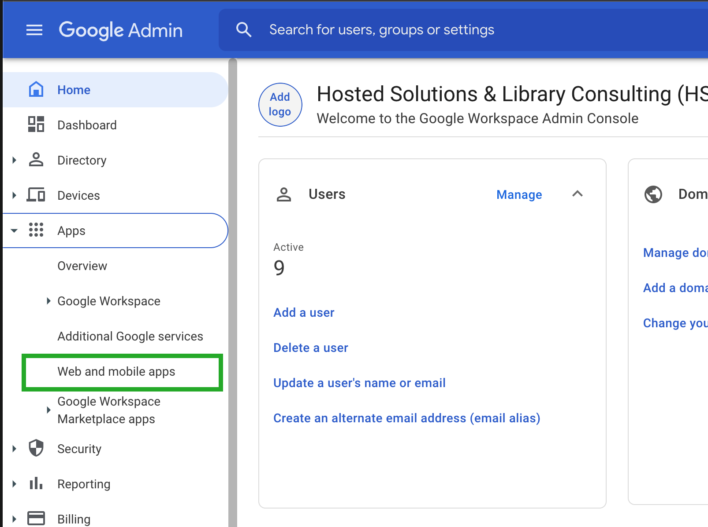
Click on your current application and select the Delete button to remove it.
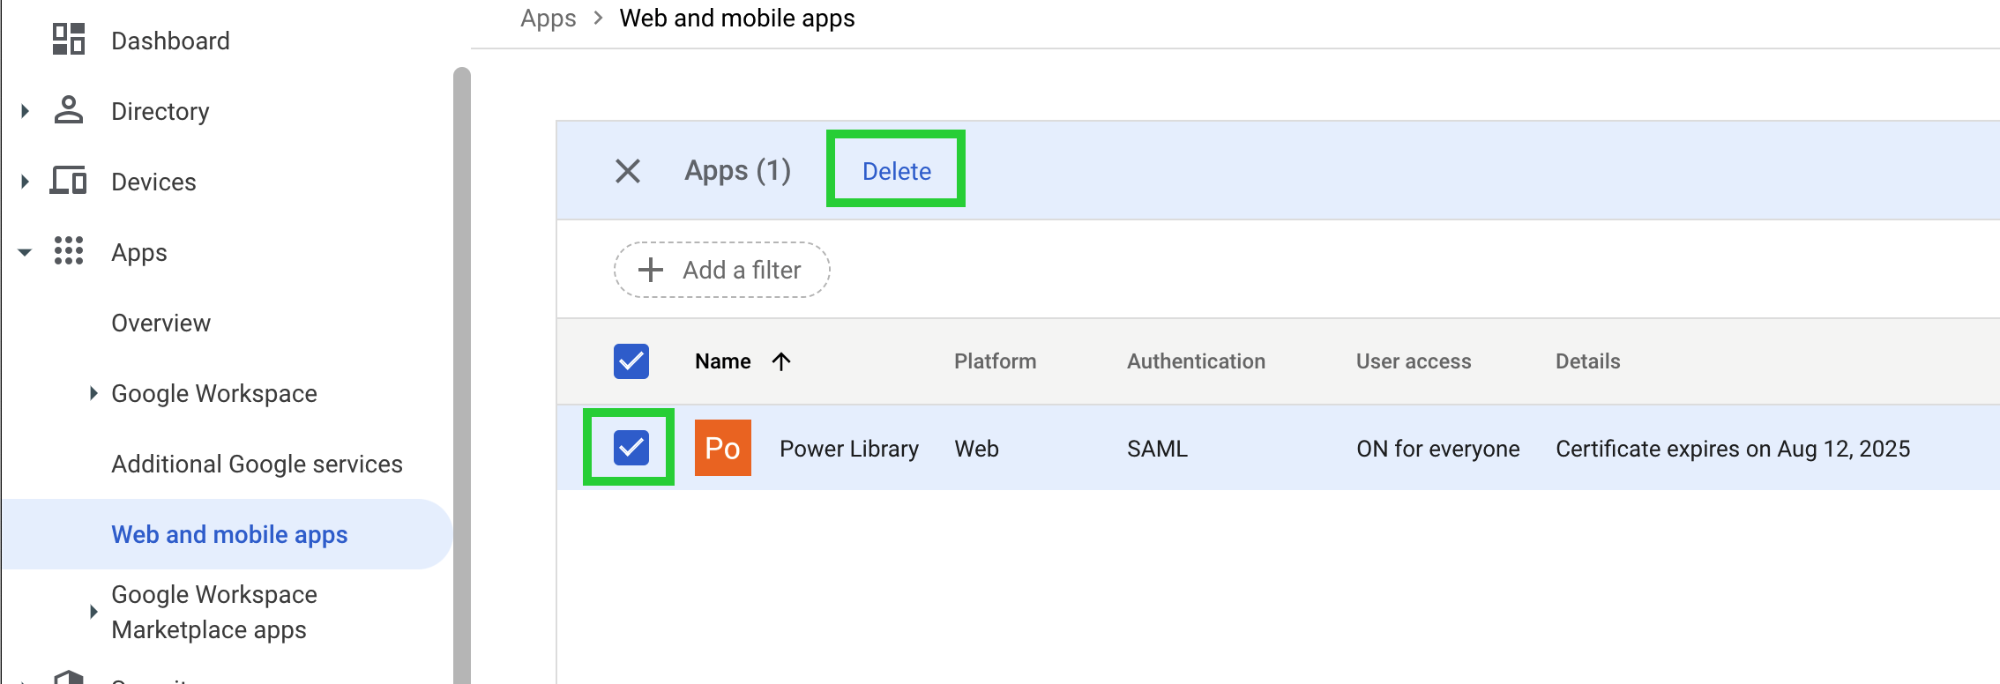
Now you can recreate it with an icon.
Click the Add App button in the upper bar.
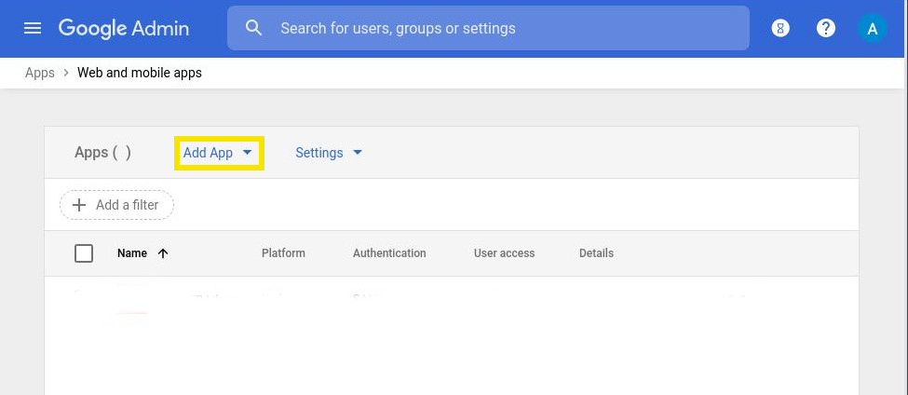
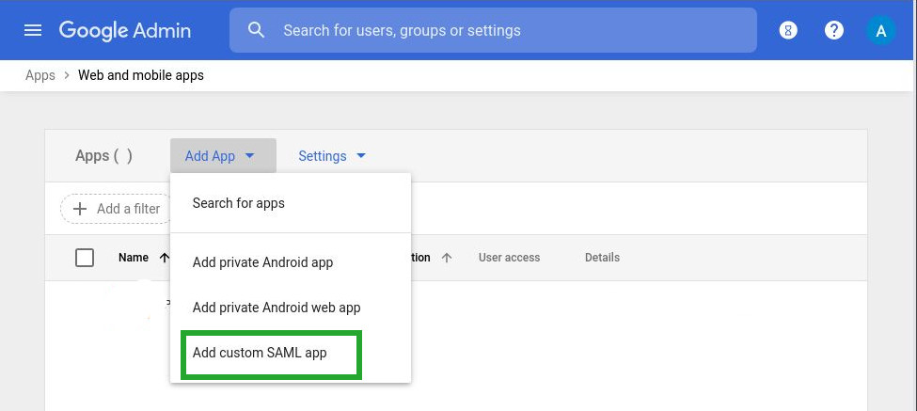
Click on Add custom SAML app.

Enter the application name as “POWER Library” and upload the Power Library Icon
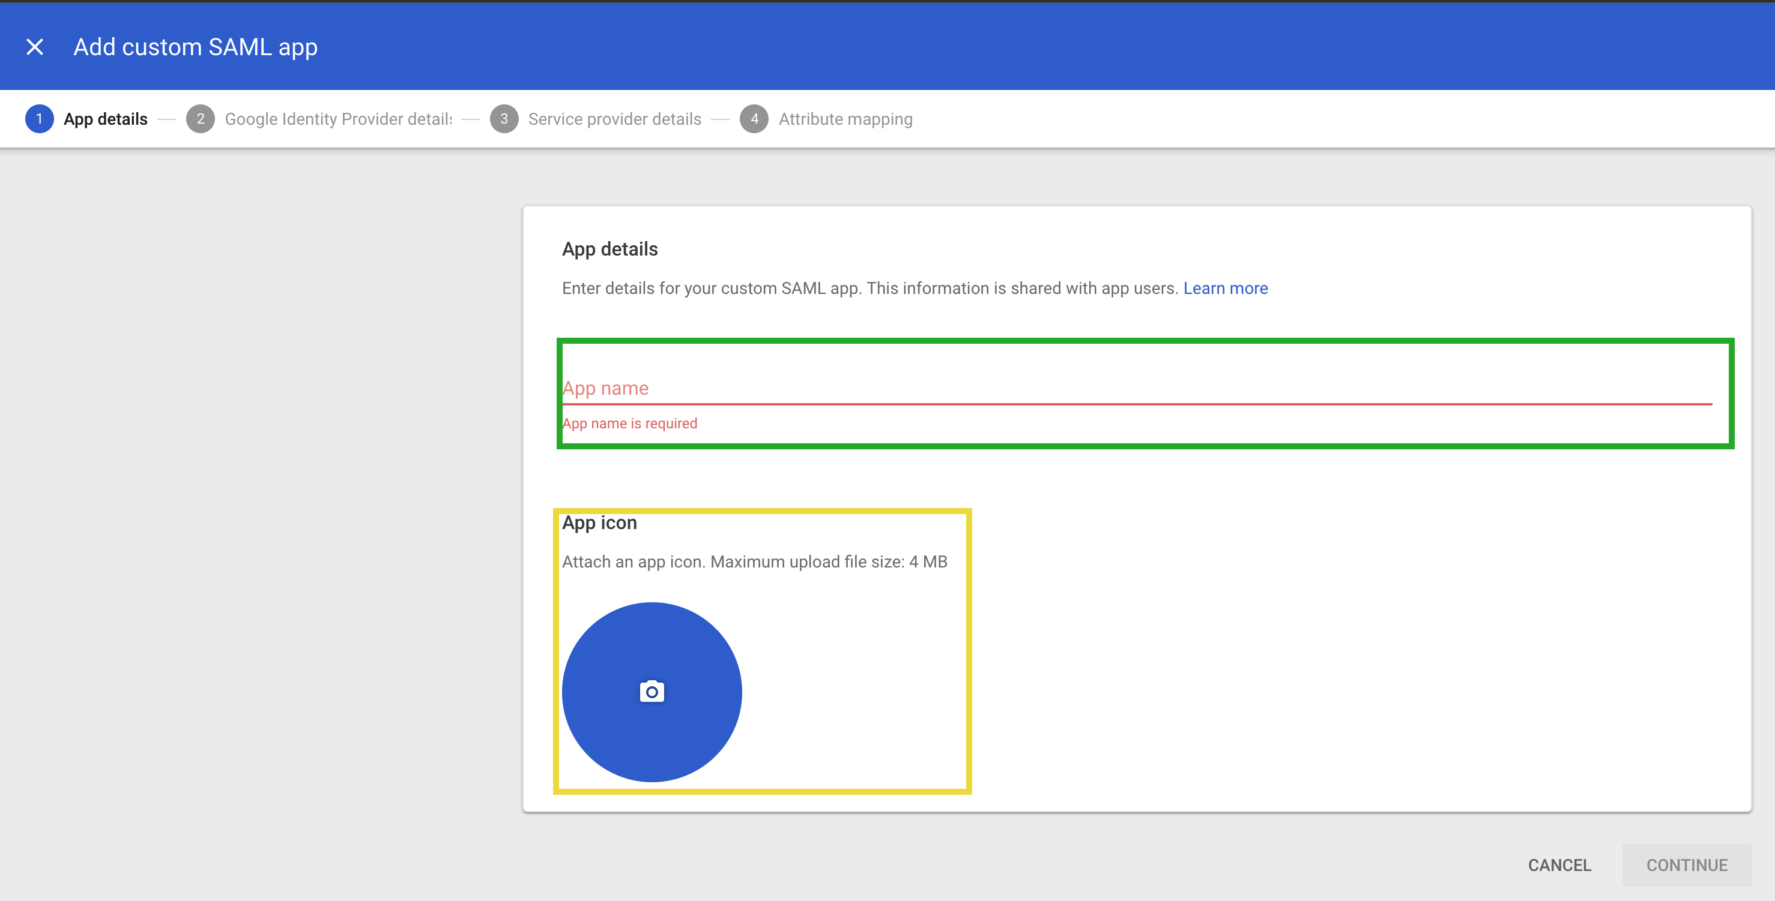
Skip downloading the metadata (Option 1&2) and just continue.
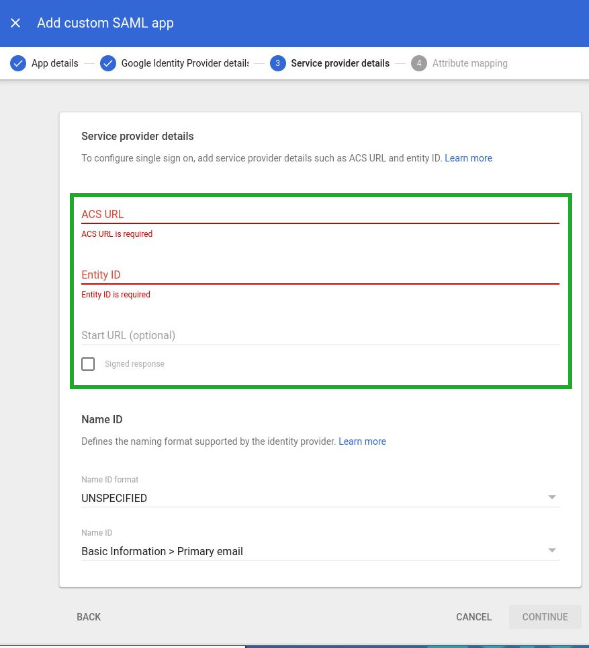
With the data above enter the ACS URL, Entity ID, and Start URL. Under Start URL select the Signed Response box. Leave the Name ID Format as UNSPECIFIED and Name ID section as Basic Information > Primary email.
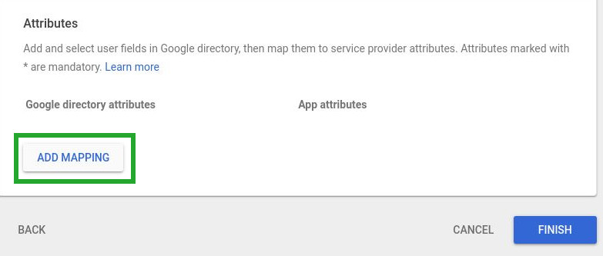
Use the Add Mapping Button to add the following mappings :Basic Information (First Name) → firstname and Base Information (Last Name) → lastname
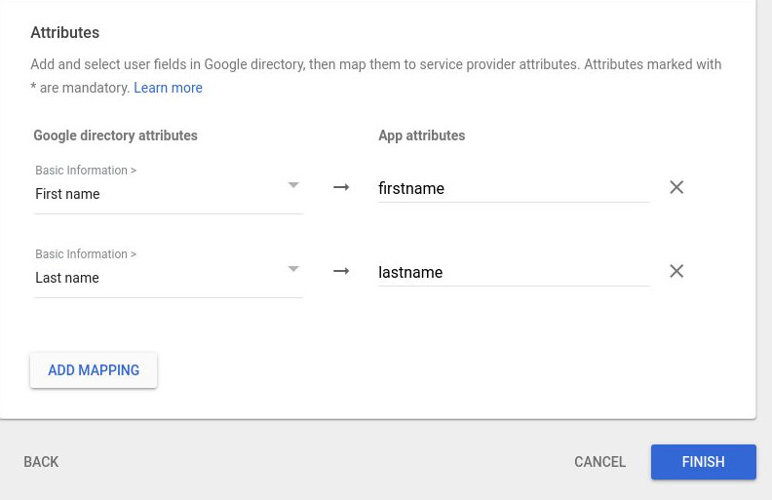
Click Finish.
Click on the down caret in the User access box.
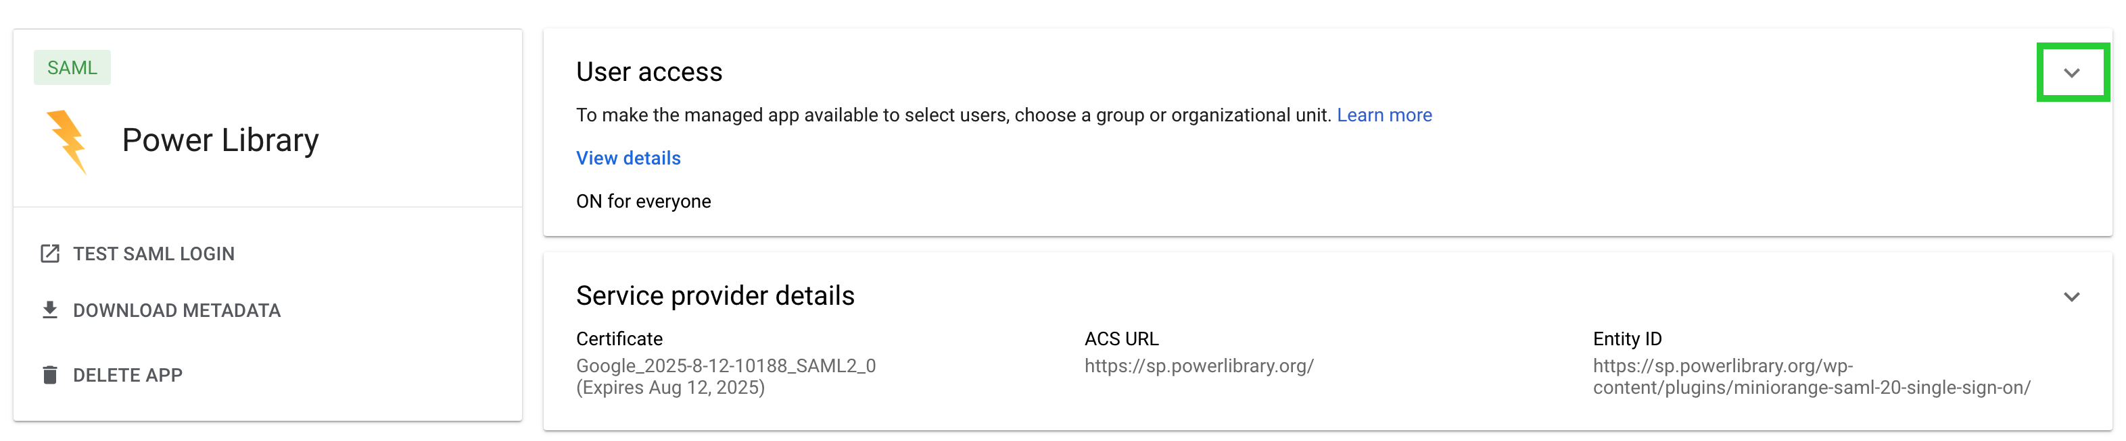
Turn on access for everyone. Click SAVE.
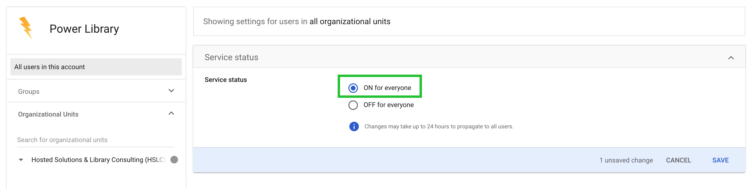
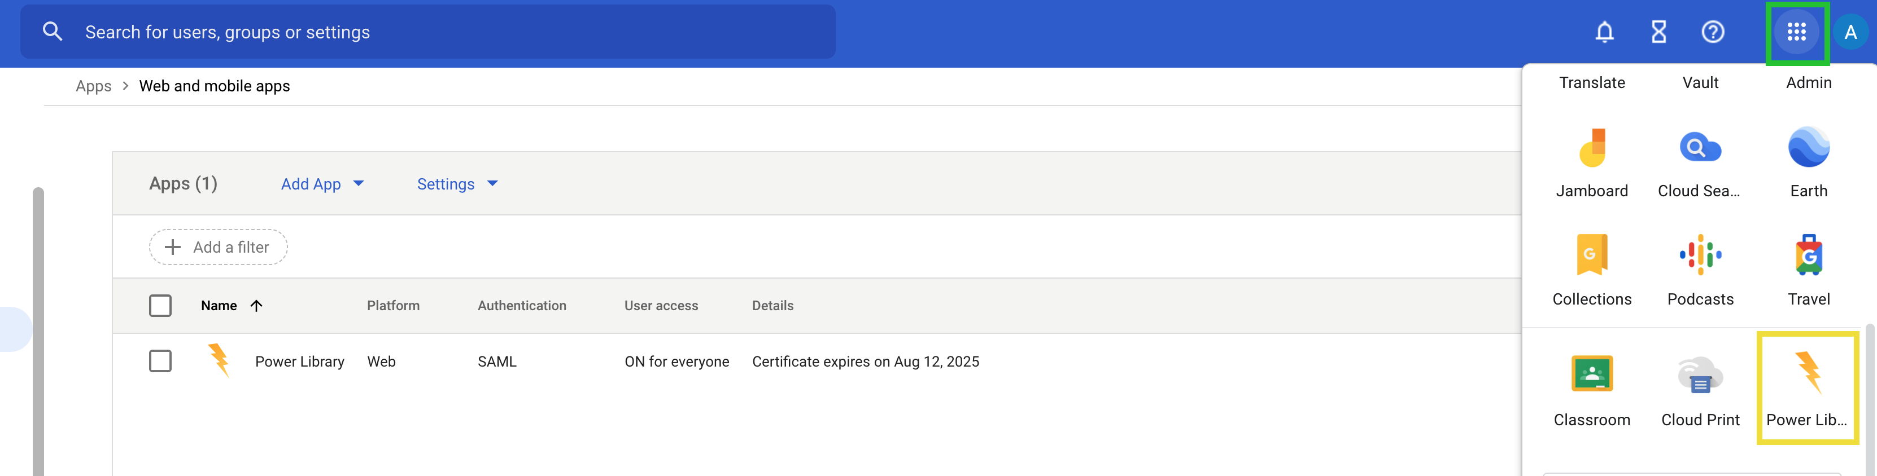
Verify app has been added by clicking the apps button and scrolling through apps. Since you have already sent us your IDP file the application will be working right away.

Questions? Please contact support@hslc.org.

